|  |  |  |  |  |
| --- | --- | --- | --- | --- |
| 5COSC021W Coursework 2 - GROUP template 2022_23  * Use this template to structure the GROUP element of coursework 2. Ensure that the correct information is in each white box. The advice for each box is basic guidance to help you focus your answer. * YOU MUST USE THIS TEMPLATE FOR THE GROUP WORK OF COURSEWORK 2.  The current size of the boxes is not indicating how much you should write; change their size as you need.When you save the file, put your name and registration number in the file name, eg ‘5COSC003W_cwk2_group_Kelly_Garret_12345678.doc’.  * A reminder of plagiarism: If you use bits of another’s group report in yours or if you give your report to another group to use this will be an academic offence called ‘collusion’. * In order for the tutors to be able to assess your work you must ensure the following for your software submission:   - Submit a zipped project folder of the **COMPLETE** working project (i.e. the parts of each group member incorporated in one program, not just your part). If you have not been able to incorporate your part with that of the group, then submit only your part – it should be able to run though by itself.  -          Make sure that the submitted project will run using the software provided by the University. Contact your tutor if you have any problems with this.  -          Make sure that the project folder should contain all files necessary to run the program e.g. excel files etc.  -          Make sure that file I/O code does not use absolute file paths.  -          Make sure that the submission contains all usernames and passwords necessary to test the program.  - Each group must upload a video describing the work in a google drive | | | | |
| **Surname** | |  | | |
| **Forename** | |  | | |
| **Registration No:** | |  | | |
| **By submitting this coursework you agree to the following:** | | | | |
| I confirm that I understand what plagiarism is and have read and understood the section on Assessment Offences in the Essential Information for Students. The work that I have submitted is entirely my own. Any work from other authors is duly referenced and acknowledged. | | | I confirm | |
| **List here the team name and the other members of your group** | | Team Name: 5SC12 & 5SE03_E  Team members:  Wallyson Alves Da Silva, Mohamed Mohamed , Joven Manikiza, Laurence Baboodal, Jimmy Le, Adam younis | | |
| Code functionality – Database implementation (10 marks) | | | |
| **Which group members worked on this:** | Mohamed Mohamed Joven Manikiza | | |
| **Guidance:**   * Describe here the tables that you finally implemented of the two databases * Describe the functionality for sink the two dbs | | | |
| In our web application, we have introduced two separate databases - LocalDatabase.db and Vaccines.db - to store and manage various data related to, mainly, appointments, patients, employees, and vaccines. The databases have been implemented with the aim to provide an efficient, secure, and reliable system to manage and retrieve data for the users, doctors and admin team.  One of the tables that we have fully implemented in the LocalDatabase.db is the 'Appointment' table. The table helps us provide or users with complete CRUD (Create, Read, Update, and Delete) functionality, allowing them to add, view, modify, and delete appointment records. This has been achieved by designing the database schema with appropriate fields, constraints, and relationships between the tables.  Another table in the same database that we have implemented full into the web app is 'patients'. This table has also been carefully crafted and used for complete CRUD functionality and allows users to manage their patient records such as personal details and joined with the ‘Appointment’ table helps locate and assign appointment details. The system has been designed to ensure data consistency and integrity by enforcing referential integrity constraints between the tables.  We also have the 'Employee' table. This table helps provide us with stored employee information and how we allow the patient to assign them an available doctor with the read functionalities. Employees that also have ‘empID’s have more privilege in the web application, those with the type of Doctor to view the vaccine information of a patient when viewing their appointment details. This has been achieved by designing the system with appropriate access control mechanisms, ensuring that only authorized personnel have access to sensitive patient data.to which, the doctor can add and store to the patient’s data in the ‘Patient’ table  Moving on to the Vaccines.db, we have implemented the 'Vaccines' table, which provides read functionality to doctors. The table stores information about various vaccines and their properties such as name, dosage, and efficacy.  With the key feature of the web application being the integration between the LocalDatabase.db and Vaccines.db. As stated before, whenever a patient makes an appointment in the LocalDatabase.db, the system automatically investigates the Vaccines.db and retrieves any relevant data corresponding to the patient. This helps in providing valuable insights to the doctors and other healthcare professionals regarding the patient's medical history and any relevant vaccinations they may have received in the past.  However, while the current implementation of the database has been effective in managing and retrieving data, there is scope for improvement in terms of testing and optimization. In the future, we would consider implementing automated testing procedures to ensure the accuracy and reliability of the data and optimizing the database schema to improve performance and reduce redundancy.  **The databases structure are:**  **LocalDatabase.db:**  The database is set with 4 tables which are the patient, appointment, staff and gp. Patient table will contain the NHS number of the patient along with the personal information such as first name, last name, postcode, email, password, DOB, gender, phone number, the GP surgery id and medical record of the patient.  the second table is the staff table where contain the employee id along with the first name, sur name, email, password, salary, position, DOB, employee type and specialisation of the doctor.  Next will come the appointment table where it holds the appointment ID, NHS number of the patient who booked the appointment, the doctor id who is assigned to the appointment, appointment time and date, completed (status of the appointment where 0 is not yet attended and 1 attended) and the appointment note.  Finally, the GP table where it holds the GP surgery name, address, email, phone number, postcode, and number of patients assigned to it. This database has been based on the initial database that has been made during the design stage excluding some columns where it has been identified by group members as unnecessary.  **Vaccine database:**  No changes has been made on this database.  In conclusion, the implementation of the LocalDatabase.db and Vaccines.db has been an essential aspect of our web application's functionality. The ability to efficiently manage and retrieve data has helped in providing a seamless experience to the users while ensuring the security and integrity of the data. | | | |

|  |  |
| --- | --- |
| Application Front End (HCI)– group part (10 marks)(if you have not been able to incorporate your work in the group project do not fill in this section, instead fill in section 2a below) | |
| **Guidance:** Attach here a screenshot of the front end of your application, incorporating the elements from each group member.   * Sum up all the main **HCI** issues of the application you have addressed and how they were addressed within the group, in particular as the individual elements came together. Include any HCI issues still remaining. * Comment on how well all parts of the application are linked * Marking of this section will also include the defence of your work during the demonstration | |
| **Members of the group**  **that worked in this:** | Wallyson Alves Da Silva Mohamed Mohamed Joven Manikiza Jimmy Le  Laurence Baboolal |

Figure - Home page

The home page has a user very simple and user-friendly design, All the links and buttons are functioning.

**Registration Page**

Figure - NHS Number

Figure - First Name

**Registration Page**

Figure – Surname

Figure - Date of Birth

**Registration Page**

Figure - Gender type

Figure - Contact details

**Registration Page**

Figure – Address

Figure - Create password

**Registration Page**

Figure - Confirm details

Figure - Registration complete

**Registration Page**

The Registration page was designed using govuk guidelines and style, ensuring that it is intuitive and easy to navigate. It’s a collection of pages that makes user interaction easy to understand and to complete the registration. The final design and the interaction were improved with the help of feedback from the team members. Validation and security were implemented in this work making sure that the user input values are correct according to what is asked on every page and that the password is encrypted when saved to in the database. Some of the HCI issues that were detected and are still present are the activation of the button on the date of birth page, where if the user inserts only the year correctly the button will become enabled and the user can press the “save and continue” button without inserting the day and month.

The other issue still present on the registration page is the “change” link on the Details Summary page, so if the user press that link, it will take him to the specific page where he wants to make changes but after pressing the “save and continue” button the user will have to insert everything else in on the next pages again.

Example: if the user is on the Detail Summary page and decides that he needs to change his email, after going to that contact details page to change the email he also will have to change their phone number and on the next page their address details and so on until he gets to the detail page again.

**Staff Login Page:**

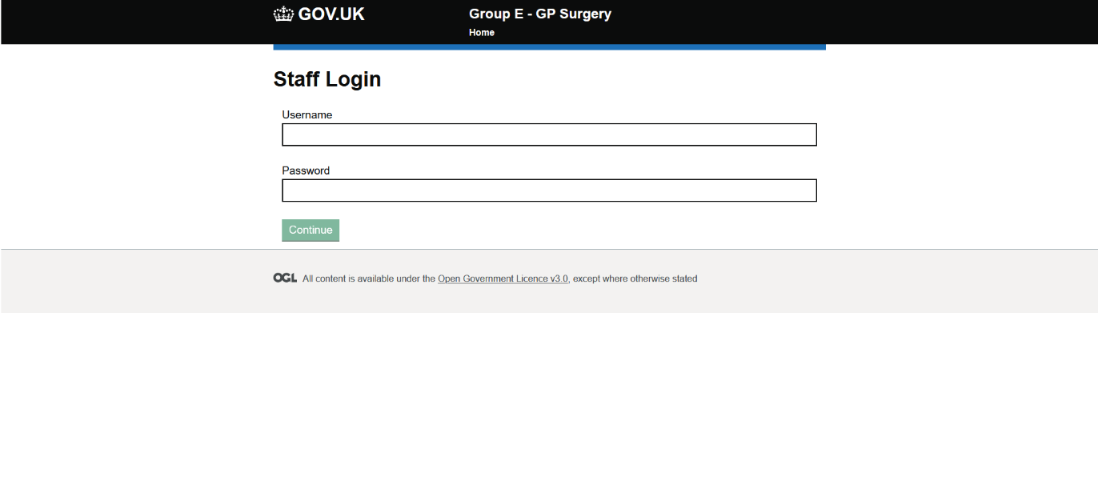

Figure 12 – Staff Login for doctor/admin

**Doctor Login Appointment Page:**

Figure 13 – Doctor appointment page

**Doctor view and update medical record Page:**

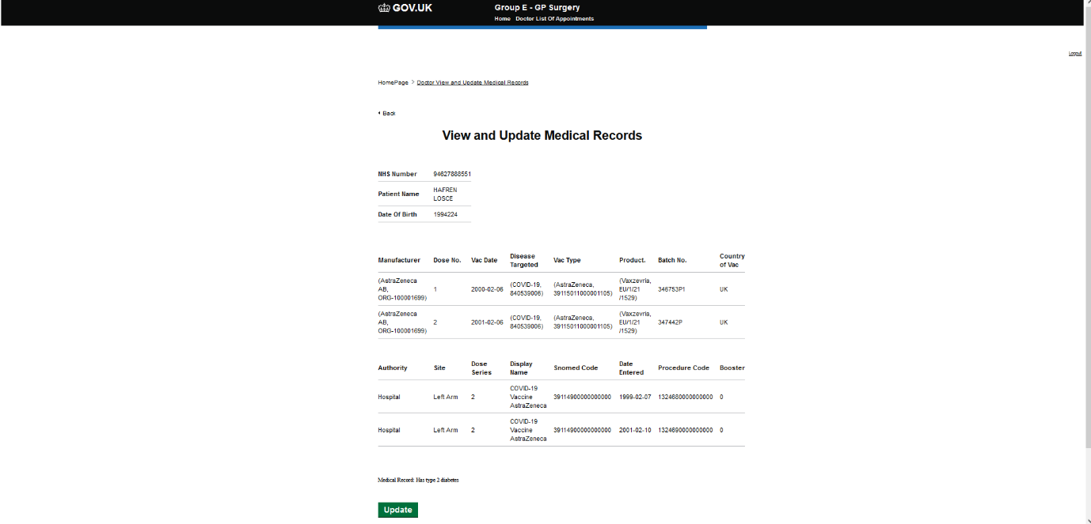

Figure 14 – Doctor view vaccine data and update medical record page.

The doctor section of the app is design with users in mind and following the GOV.uk design to ensure user compatibility and ease of use. The website contain validation during login to ensure that user will be able to check if the information entered while attempting to login is correct or not and act based on the outcome. the appointment will be displayed to the doctor in a form of a table as it is design to organise the appointment and make it easy to identify patient and update their data.

Next page will be the view and update medical record where doctor will be guide to the specific user medical record once they identify them as each user row has a button that will take them to the medical record. The design is well link and structure for any individual to use it easily no matter their technical knowledge. All the function of the doctor side are functional and medical record along with appointment will be updated according to user input. If the doctor has updated the user medical record and save the information, it will no longer display it to the doctor as it will set to complete. All the doctor section contains a logout to ensure that the user will be able to exit at any time.

**Patient login page:**

Figure 15 patient login page

The login page has been thoughtfully designed using GOVUK components to ensure both style consistency and ease of usability for the user. Serving as the primary point of access to any page that requires a login, this page is crucial to the overall user experience. Anchor links have been thoughtfully incorporated into the design, allowing for effortless navigation to other members' pages. Moreover, the implementation of input validation and sanitization security measures ensures that users are unable to submit invalid or potentially harmful inputs.

The login form has been programmed to perform checks against the database to verify the validity of the email address and password entered by the user. In the event of a successful match, the user will be directed to the relevant page, whereas incorrect login details will trigger the display of an error message for either the email or password. Seamless connectivity to other protected pages has been implemented through redirection of users to /login if they attempt to access a protected page without proper login credentials.

Overall, the login page has been expertly crafted to offer a secure and seamless user experience, making it a crucial component of the website's functionality.

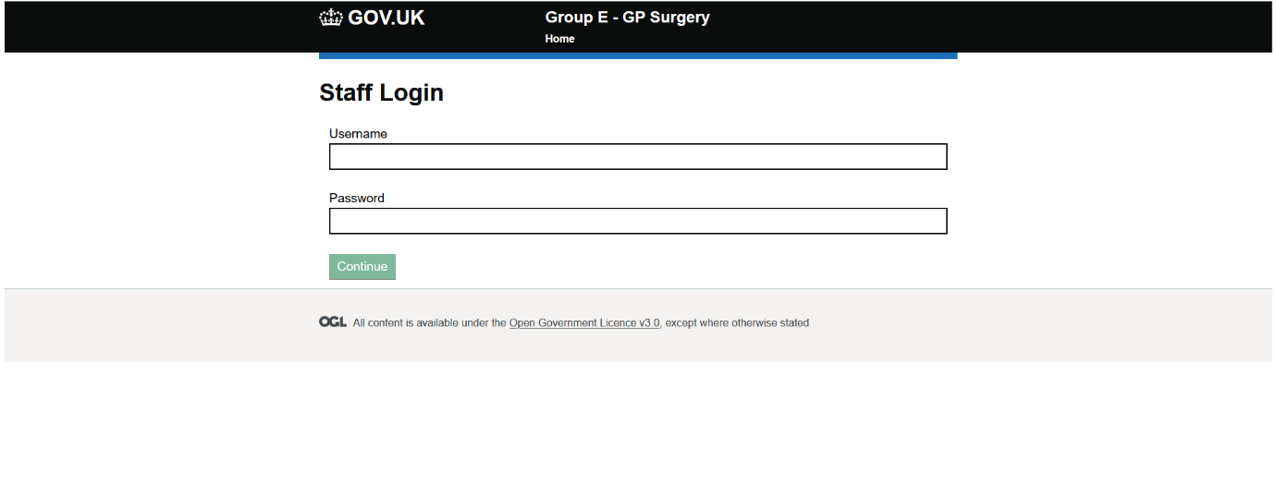

Figure 16 staff login page

The staff login page uses the same design language as the patient login page, offering a unified and seamless user experience. As the first point of access to pages protected pages for staff members, this login page plays an important role in ensuring secure and authorised access to sensitive information.

Like the patient login page, the staff login form has security measures in place, including input validation and sanitization, to prevent the entry of invalid or malicious code. Upon submission of the login credentials, the form performs checks against the database to verify the validity of the email address and password entered by the user. A successful match triggers the user's redirection to the relevant page.

However, it is important to note that the staff login credentials were hard coded in this implementation, which may raise security concerns. While the use of hard-coded credentials may have been a temporary solution, it is not considered a best practice.

**Patient navigation page:**  
Figure 17 patient navigation page  
  
The patient navigation page was designed to inform the user of the web application and what they can perform with its easy to use system, ensuring that the user can easily navigate to the GP services page and their profile page. The design adheres to GOV.uk guidelines to ensure user compatibility and ease of use. The pages are intuitive and easy to navigate, with a clean layout and clear calls-to-action.

**  
*Figure 18 patient profile page*

The patient profile page of the application is a shining example of a user-centered design that is both simple and effective. The page has been designed with the user in mind, and the emphasis is on making it easy for them to manage their personal information.

One of the main strengths of the patient profile page is its simplicity. The layout is clean, uncluttered and intuitive, which makes it easy for the user to find the information they need quickly. The use of white space, clear typography, and a consistent color scheme helps to enhance the readability and visual appeal of the page.

The patient information section displays the user's personal details in a table format, which is easy to read and navigate. The table is well-organized, and each field is clearly labelled to ensure that the user knows what information they are looking at. The use of icons *could* have been used to indicate different types of information, such as a telephone icon for the user's phone number, makes the table more visually appealing and helps to emphasize the importance of each field.

One of the most useful features of the patient profile page is the ability for the user to edit their personal details. The page has been designed to make the process of editing personal information as seamless as possible. The user simply needs to click on the "Change" button located next to each field they want to update, make the necessary changes, and click on the "Confirm" button. The changes are then reflected in the table immediately and once they navigate to profile again, will give the user instant feedback that their changes have been successfully saved.

In conclusion, the patient profile page is an excellent example of a well-designed user interface. The page is simple, clean, and effective, with a clear focus on user-centered design principles. The information is displayed in an appealing and easy-to-understand format, which makes it simple for the user to navigate and edit their personal information. Overall, this page is a great example of how good design can improve the user experience and make it easier for patients to manage their health information.

**Figure 19 GP Services – View/Cancel Appointment page

Figure 20 GP services – Book appointment page

Figure 21 GP Services – Doctors available page

Figure 21 GP services – Deregister page

The GP Services page is a prime example of how simplicity can make a webpage more efficient. The use of tabs to categorize the various services provided by the general practice ensures that users can easily navigate to the service they require. The layout is clean and uncluttered, with a consistent design throughout the page, providing a seamless user experience.

In the Doctors Available tab, the webpage pulls data from the database and presents it in an organized and structured way. The data is displayed in a table, which is easy to read and navigate, making it simple for users to find the doctor they need. The table is organized by name, specialization, and contact details, enabling users to find the information quickly and efficiently that they require.

The Book Appointment tab provides users with a simple and easy way to book an appointment. The radio button provides users with a choice of morning, noon, or afternoon appointments, and the drop-down menu enables them to select the doctor they prefer. This uncomplicated design ensures that booking an appointment is a smooth and quick process.

The View/Cancel Appointment Tab is an effortless way for users to view any appointments they have booked. The date, time, and doctor details are displayed in a clear and concise manner, making it easy for users to identify their appointments. The cancel button is prominently displayed, allowing users to cancel any appointments quickly and easily that they are unable to attend.

The De-register Tab is a simple and efficient way for users to de-register from the GP. Users are presented with a yes or no option, followed by two separate alerts to confirm their decision. This straightforward design ensures that users can easily navigate the webpage and terminate their patient data with the current GP.

Overall, the GP Services page is another shining example of how simple design and organization can improve the user experience. The use of tabs to categorize the various services and clean, uncluttered design makes it easy for users to find the information they require and complete their desired actions quickly and efficiently.

**Admin panel page:**

The admin panel page has 2 main functions to retrieve all the patient appointments and to also delete patient appointments. It notifies the user if invalid input is entered or a ID that does not exist is entered, it will also notify the user when an appointment is successfully removed from the database. You can see this in the pictures above. There are no HCI issues on this page it is all straightforward and understandable.

|  |  |
| --- | --- |
| Application Front End (SECURITY)– group part (10 marks) | |
| **Guidance:**   * Sum up all the main **security** issues of the application and how they were addressed   and any security risks still remaining   * Marking of this section will also include the defence of your work during the demonstration | |
| **Members of the group**  **that worked in this:** | Laurence Baboodal |

Authentication: This is making sure that only authorised users can access sensitive parts of the application such as the admin or employee part. We implemented this by making a login to access any sensitive pages the passwords are also stored as hashed in the database not plaintext. We have also used private routs in react routers for all the important pages, this is to make sure the user can not just type in the URL and access the important pages.

SQL injection: This is an attack technique where attackers can send malicious SQL queries as input to prevent these attacks, we have only used prepared statements and PDO

Insecure authentication: This is when authentication is implemented but poorly for example using an easy to guess password like 123 for are application, we have used complex passwords.

XSS: Cross-Site Scripting (XSS) attacks are a type of injection, in which malicious scripts are injected into websites. XSS attacks occur when an attacker uses a web application to send malicious code, generally in the form of a browser side script, to a different end user. To prevent this, we used DOM Purify in our application to sanitise HTML.

|  |  |
| --- | --- |
| Professional conduct: Legal & Ethical (10 marks) **4.1 Legal** | |
| **Which group members worked on this:** | Wallyson Alves Da Silva |
| **Guidance:** List here the legal issues that would affect both the development and the use of your application. You need to support this work with research. The marks in this section also include marks for references (see end of document). | |
| There are several legal issues that could affect the development and use of this application for GP surgery. Starting from data protection, we certainly need to ensure that the application is designed in a way that is compliant with data protection regulations, such as the General Data Protection Regulation, which requires personal data to be collected and processed in a lawful and transparent manner.  Confidentiality, maintaining patient medical records and personal information secure is another key concern that we should always have in count when developing any sort of application that handles customer data. This will include using secure methods for the implementation of access control.  Implementing appropriate security measures to protect from unauthorized access, using encryption and implementing secure authentication mechanisms can help protect against data breaches and the integrity of the application.  Developers must ensure that they have the necessary permissions and licenses for the use of any third-party software or libraries used in the application and ensure that the application does not infringe any intellectual property rights, such as patents or copyrights.  It is important to seek for legal advice and to stay up to data with the latest laws and regulations. | |

|  |  |
| --- | --- |
| Professional conduct – Legal & Ethical4.2 Ethical | |
| **Which group members worked on this:** | Mohamed Mohamed, Laurence Baboodal |
| **Guidance:** With the aid of a table list here the ethical issues that would affect both the development and the use of your application. You need to support this work with research. The marks in this section also include marks for references (see end of document). | |
| there are several ethical issue that we have identified and handle during the development which include:   |  |  |  | | --- | --- | --- | | **Ethical Issue** | **Description** | **References** | | **Privacy/Confidentiality** | **We will be storing patient information that is highly confidential and private this means that we would need to implement the correct security features to safely store the data and handle it. We would also need to follow the correct data protection regulations.** | 1. **World Health Organization. (2018). Data privacy and security principles for health apps and other digital health technologies.** [**https://www.who.int/data-protection/data-privacy-and-security-principles-for-health-apps.pdf**](https://www.who.int/data-protection/data-privacy-and-security-principles-for-health-apps.pdf)   **2.** **General Data Protection Regulation (GDPR). https://gdpr.eu/** | | **Consent to process data** | **Personal information will be collected and used, we would need to explicitly state how the information will be used and if it will be shared with third parties. We also need to respect their autonomy and privacy this could mean only allowing the respective employees to view this data.** | **1.** **General Data Protection Regulation (GDPR). https://gdpr.eu/** | | **Accessibility** | **Accessibility for everyone, including those with impairments, is required for the website. To address this issue, it is crucial to make sure the website is built with accessible features that adhere to the pertinent accessibility requirements. For example, to make are site more accessible it also works on mobile and tablets as well as desktop.** | 1. **Web Content Accessibility Guidelines (WCAG) 2.1.** [**https://www.w3.org/TR/WCAG21/**](https://www.w3.org/TR/WCAG21/) | | **Professional Conduct** | **The website should conform to moral and professional standards, such as refraining from conflicts of interest, guaranteeing the truth and reliability of the data provided, and upholding the rights and dignity of patients.** | **1.** **Nursing and Midwifery Council. (2018). The code: Professional standards of practice and behaviour for nurses, midwives, and nursing associates. London: Nursing and Midwifery Council.** |   In depth explanation for some of the key points:   1. Privacy and confidentiality:   The user’s privacy is one of the issues we have identified and handled throw protected the data passed to the database along with protecting each user account by validating data enter during login and using authentication for the user.  Furthermore, misuse of personal data is another major issue that users deal with as corporation attempt to collect user data throw almost everything such as browsing on the web or using social media to collect data and use it to personalize ads to user to increase in their profit. Such issue is a violation of user privacy which our project does not violate as we offer no sales or custom services based on user data ensure everything is fully decided by user as needed bases.   1. Bias and Discrimination:   Treating users unfairly us another issue that has been identified and handled during the implementation process as we have ensured all users access are the same and no limitation has been set for any reason to ensure access is provided to everyone.   1. Accountability and responsibility:   As most corporations use third parties to process data, handle payment, user privacy is at risk of violation and no responsibility has been taken by any particular group once data are preached. Such issue has been faced by many developers as they attempt to build a self-sustaining program to ensure no other parties will be required to handle the data and store it for their personal use. For this project, we have created a self-sustaining project as the project does not require any third part services to handle user data ensure that no data can be breached by other beneficiaries and responsibility will fall solely on the organization that launched and using the program. | |

|  |
| --- |
| References (marks included in each of the main sections) |
| Section 4 must be supported by research.List below your sources, using Harvard referencing. Make sure that your references are referred to correctly from the relevant text of your work. **If you are not clear how to reference read:**  **https://www.westminster.ac.uk/library-and-it/support-and-study-skills/guides-and-tutorials/referencing-your-work** Here’s how we’ll assess it:  * No research sources: that’s very bad for level 5 work * There is one source with all information, copied directly as if it’s your own text: that is plagiarism * There is one source with all information, referenced and discussed: that is bad research * There are a few different sources, referenced and discussed in the text: this is getting better * There are quite a few good sources from many different places, referenced and discussed in the text: this gets good marks. |
| **Section 4.1 references** |
| ICO.  Principle (f): Integrity and confidentiality (security)  <https://ico.org.uk/for-organisations/guide-to-data-protection/guide-to-the-general-data-protection-regulation-gdpr/principles/integrity-and-confidentiality-security/>  ICO.  Encryption  <https://ico.org.uk/for-organisations/guide-to-data-protection/guide-to-the-general-data-protection-regulation-gdpr/security/encryption/> |
| **Section 4.2 references** |
| Confidentiality: good practice in handling patient information  <https://www.gmc-uk.org/ethical-guidance/ethical-guidance-for-doctors/confidentiality>  Panel®, E. (n.d.). *Council Post: 10 Current And Potential Ethical Crises In The Tech Industry*. [online] Forbes. Available at: https://www.forbes.com/sites/forbestechcouncil/2021/07/30/10-current-and-potential-ethical-crises-in-the-tech-industry/.  ‌ World Health Organization. (2018). Data privacy and security principles for health apps and other digital health technologies. <https://www.who.int/data-protection/data-privacy-and-security-principles-for-health-apps.pdf>  General Data Protection Regulation (GDPR). <https://gdpr.eu/>  Web Content Accessibility Guidelines (WCAG) 2.1. <https://www.w3.org/TR/WCAG21/>  Nursing and Midwifery Council. (2018). The code: Professional standards of practice and behaviour for nurses, midwives, and nursing associates. London: Nursing and Midwifery Council. |